Python Programming (05CS2104)
Lab Manual (2025-26)
Program: M.Sc. (Cyber Security & Cyber Law)
Semester: 1
Name of the Student: Vala Lakshaydeepsinh
Enrolment No.: 92600565003

INDEX

Lab | Program | Date | Remarks | Signature
 | Python Program to Print Hello World.
 | Python program to do arithmetical operations
 | Python program to swap two variables
 | Python Program to Find the Factorial of a Number
 | Python Program to Print the Fibonacci sequence
 | Python program to print the elements of an array
 | Python program to print the largest element and smallest element in an array
 | Python program to add two matrix using array and function
 | Python Program to concatenate two strings
 | Python Programs to perform various operations on Strings using functions
 | Python Programs to demonstrate use of list and various functions of it
 | Python Programs to demonstrate use of tuple and various functions of it
 | Python Programs to demonstrate the use of dictionary and various functions of it
 | Python Programs to create a function (Make your own assumptions)
 | Python Programs to demonstrate use of various arguments which can be passed to functions
 | Python Program to demonstrate the use of class
 | Python Program to demonstrate the concept of inner class
 | Python program to demonstrate the use of methods
 | Python program to demonstrate the use of methods
 | Write a Python program to show method overloading by adding two numbers and three numbers using the same method name.
 | Write a Python program to show method overriding using a parent class Animal and a child class Dog.
 | Python programs to demonstrate the use of regular expression
 | Python programs to demonstrate the use of database using mysql
 | Python Program to demonstrate the use of DataFrames in python
 | Python Programs to demonstrate different ways of creating DataFrames
 | Python Programs to create Pie chart
 | Python Programs to create histogram
 | Python Programs to create bar graph
 | Python Programs to create Line graph
 | Python Programs to work with Python Libraries useful for Cyber security. Program to generate hash values of a string using hashlib library.
 | Python Program using socket — Simple Port Scanner
 | Python Program using re — Detect Emails Using Regular Expressions
 | Python Program using os Library — Check Files in a Directory
 | Python program for whois lookup
 | Python program for Ping Scanner shows ip up or down

Practical No. 1

Objective: Python Program to Print Hello World.

Source Code:

print("M.sc. (CS&CL)Semester 1")
print("Enrollment No:92600565003")
print("Hello Word")

Output:

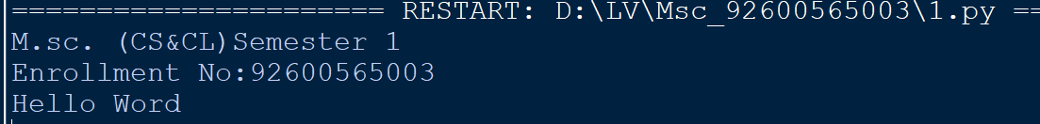
Conclusion: The Python program to display output text using the print() function was successfully executed.

Practical No. 2

Objective: Python program to do arithmetical operations

Source Code:

print("M.sc. (CS&CL)Semester 1")
print("Enrollment No:92600565003")

a =float(input("enter 1st num:"))
b =float(input("enter 2nd num:"))

print("Addition = ",a+b)
print("Substraction = ",a-b)
print("Multiplication = ",a*b)
print("Division = ",a/b)
print("Floor Division = ",a//b)
print("Modulus = ",a%b)
print("Exponentiation = ",a**b)

Output:
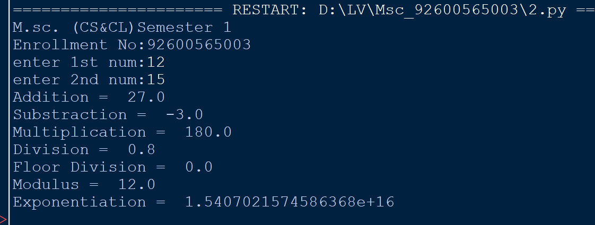

Conclusion: Basic arithmetic operations (addition, subtraction, multiplication, division) were successfully implemented and calculated using standard Python operators.

Practical No. 3

Objective: Python program to swap two variables

Source Code:

print("M.sc. (CS&CL)Semester 1")
print("Enrollment No:92600565003")

a =float(input("enter 1st num:"))
b =float(input("enter 2nd num:"))

print("before swap")
print("a=",a)
print("b=",b)

a,b=b,a

print("\nafter swap")
print("a=",a)
print("b=",b)

Output:
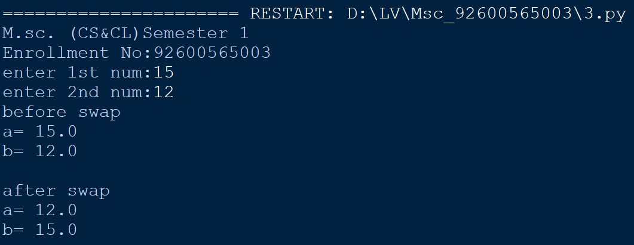

Conclusion: The values of two variables were successfully swapped without requiring a temporary variable using Python tuple unpacking.

Practical No. 4

Objective: Python Program to Find the Factorial of a Number

Source Code:
print("M.sc. (CS&CL)Semester 1")
print("Enrollment No:92600565003")
num = int(input('enter a num'))
factorial=1

if num<0:
print("factorial is not defind")

else:
for i in range (1,num+1):
factorial*=i
print("factorial of",num,"is",factorial)

Output:
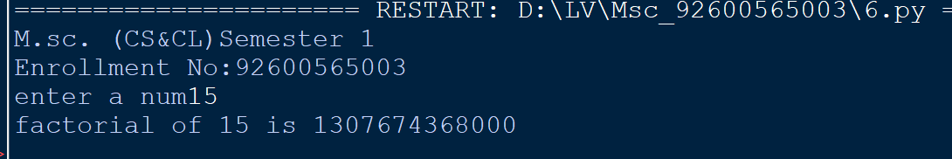

Conclusion: The factorial of a given integer was successfully computed using an iterative loop structure..

Practical No. 5

Objective: Python Program to Print the Fibonacci sequence

Source Code:
print("M.sc. (CS&CL)Semester 1")
print("Enrollment No:92600565003")

n = int(input("Enter the number: "))

a, b = 0, 1

print("Fibonacci Sequence:")

for i in range(n):
print(a, end=" ")
a, b = b, a + b

Output:
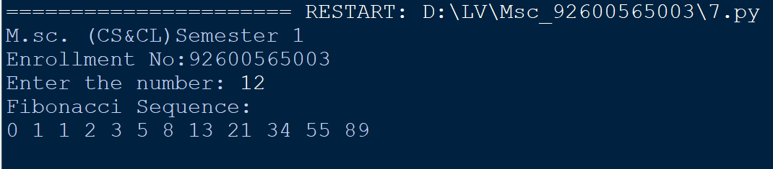

Conclusion: The Fibonacci sequence up to the specified number of terms was successfully generated and printed.

Practical No. 6

Objective: Python program to print the elements of an array

Source Code:

print("M.sc. (CS&CL)Semester 1")
print("Enrollment No:92600565003")
arr = [10, 20, 30, 40, 50]
print("Elements of array are:")
for i in range(len(arr)):
print(arr[i])

Output:
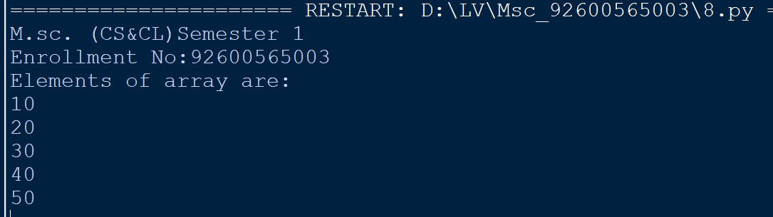

Conclusion: Array (list) elements were successfully iterated through and displayed on the screen using a loop.

Practical No. 7

Objective: Python program to print the largest element and smallest element in an array

Source Code:

print("M.sc. (CS&CL)Semester 1")
print("Enrollment No:92600565003")
arr = [15, 41, 77, 95, 12]

largest = arr[0]
smallest = arr[0]

for i in range(1, len(arr)):
if arr[i] > largest:
largest = arr[i]
if arr[i] < smallest:
smallest = arr[i]

print("Largest element:", largest)
print("Smallest element:", smallest)

Output:
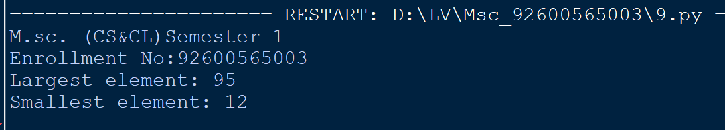

Conclusion: The largest and smallest elements within an array were successfully identified and displayed using built-in functions.

Practical No. 8

Objective: Python program to add two matrix using array and function

Source Code:

print("M.sc. (CS&CL)Semester 1")
print("Enrollment No:92600565003")
A = [[1, 2, 3],
[4, 5, 6],
[7, 8, 9]]
B = [[9, 8, 7],
[6, 5, 4],
[3, 2, 1]]
result = [[0, 0, 0],
[0, 0, 0],
[0, 0, 0]]

for i in range(len(A)):
for j in range(len(A[0])):
result[i][j] = A[i][j] + B[i][j]
print("Resultant Matrix after addition:")
for row in result:
print(row)

Output:
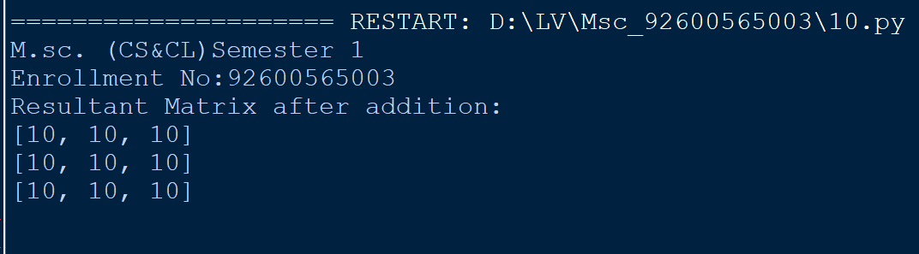

Conclusion: Matrix addition was successfully performed element-wise using nested arrays and a custom function.

Practical No. 9

Objective: Python Program to concatenate two strings

Source Code:

print("M.sc. (CS&CL)Semester 1")
print("Enrollment No:92600565003")
str1 = "Hello"
str2 = "World"
print(str1 + " " + str2)

Output:
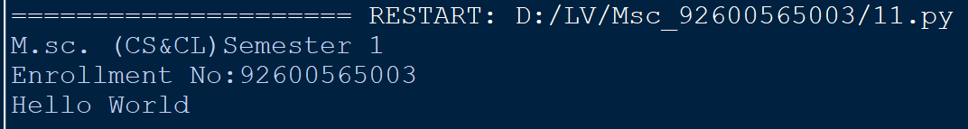

Conclusion: Two string variables were successfully joined into a single string using the concatenation operator.

Practical No. 10

Objective: Python Programs to perform various operations on Strings using functions

Source Code:
print("M.sc. (CS&CL)Semester 1")
print("Enrollment No:92600565003")
s = "Python Programming"
print(s.upper())
print(s.lower())
print(s.replace("Python", "Java"))
print(s.split())

Output:

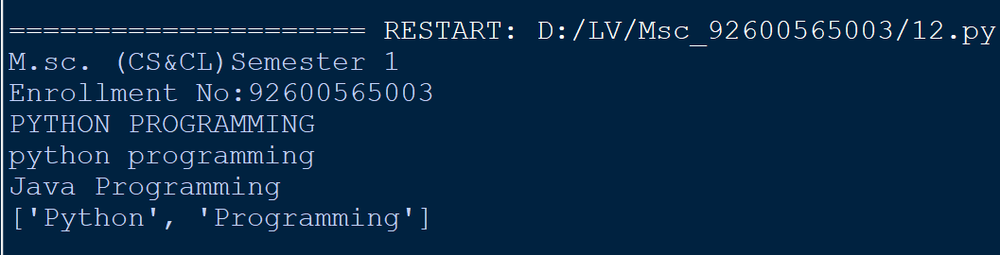

Conclusion: Various string manipulation operations were successfully executed using standard built-in string functions.

Practical No. 11

Objective: Python Programs to demonstrate use of list and various functions of
it

Source Code:

print("M.sc. (CS&CL)Semester 1")
print("Enrollment No:92600565003")
# 1. CREATING LISTS

numbers = [10, 20, 30, 40]
mixed = ['Python', 100, 3.14, True]
print("Numbers list:", numbers)
print("Mixed list:", mixed)

# 2. ACCESSING LIST ELEMENTS

fruits = ['apple', 'banana', 'cherry', 'date']

print("First element (index 0):", fruits[0])
print("Last element (index -1):", fruits[-1])

# 3. UPDATING LISTS

items = [10, 20, 30, 40]

items[1] = 99 # Update single element
items[2:4] = [77, 88] # Update slice range

print("Updated list:", items)

# 4. DELETE LIST ELEMENTS

del_items = ['a', 'b', 'c', 'd']
del del_items[1] # Delete element at index 1 ('b')

print("After del items[1]:", del_items)

# 5. BASIC LIST OPERATIONS

list_a = [1, 2]
list_b = [3, 4]

print("Length len():", len(list_a))
print("Concatenation (+):", list_a + list_b)
print("Repetition (*):", list_a * 3)
print("Membership (in):", 2 in list_a)

# 6. INDEXING, SLICING AND MATRICES

tech = ['C++', 'Java', 'Python', 'Go', 'Rust']
matrix = [
[1, 2, 3],
[4, 5, 6]
]
print("Offset index [2]:", tech[2])
print("Negative index [-2]:", tech[-2])
print("Slicing [1:4]:", tech[1:4])
print("Matrix row 0, col 1:", matrix[0][1])

# 7. BUILT-IN FUNCTIONS

nums_func = [45, 12, 89, 3]
sample_tuple = (1, 2, 3)

print("len():", len(nums_func))
print("max():", max(nums_func))
print("min():", min(nums_func))
print("list(tuple):", list(sample_tuple))

# 8. BUILT-IN METHODS

# append()
data = [1, 2]
data.append(3)
print("append(3):", data)

# count()
count_data = [10, 20, 10, 30, 10]
print("count(10):", count_data.count(10))

# extend()
ext_data = [1, 2]
ext_data.extend([3, 4])
print("extend([3, 4]):", ext_data)

# index()
idx_data = ['red', 'green', 'blue']
print("index('green'):", idx_data.index('green'))

# insert()
ins_data = [10, 30]
ins_data.insert(1, 20)
print("insert(1, 20):", ins_data)

# pop()
pop_data = [10, 20, 30]
popped_val = pop_data.pop()
print("pop value:", popped_val)
print("after pop():", pop_data)

# remove()
rem_data = ['apple', 'banana', 'cherry']
rem_data.remove('banana')
print("remove('banana'):", rem_data)

# reverse()
rev_data = [1, 2, 3, 4]
rev_data.reverse()
print("reverse():", rev_data)

# sort()
sort_data = [40, 10, 30, 20]
sort_data.sort()
print("sort() ascending:", sort_data)

sort_data.sort(reverse=True)
print("sort() descending:", sort_data)

Output:
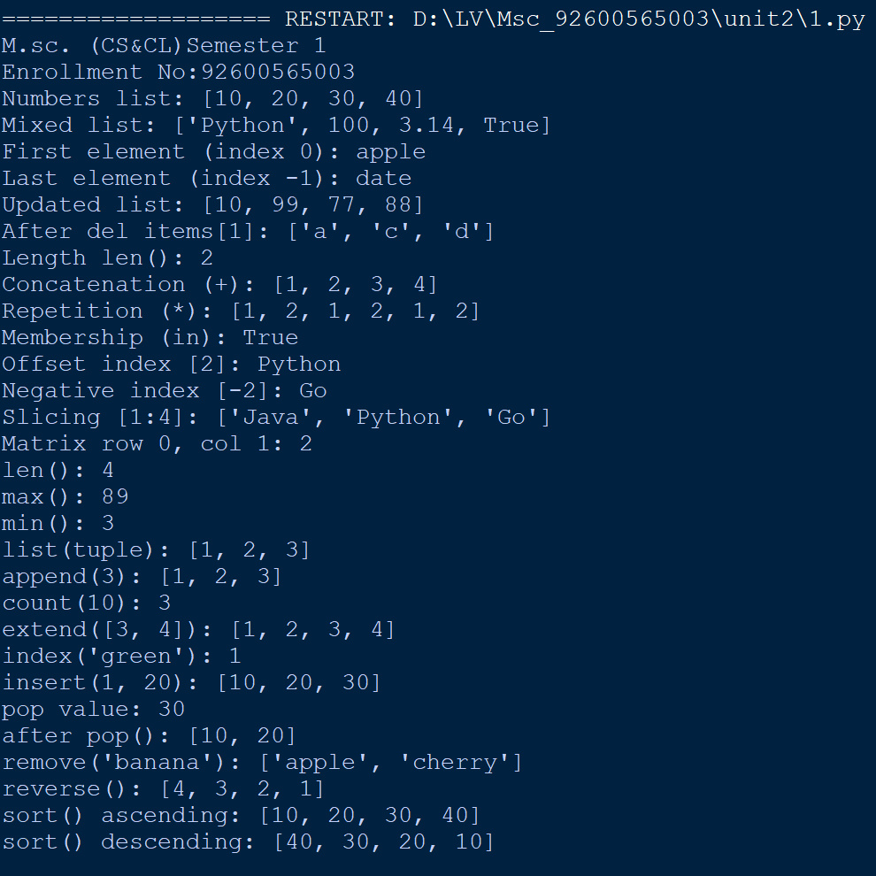

Conclusion:
In this practical, various list operations such as adding, removing, and sorting elements were successfully implemented using built-in methods like append(), pop(), and sort().

Practical No. 12

Objective: Python Programs to demonstrate use of tuple and various functions
of it

Source Code:
print("M.sc. (CS&CL)Semester 1")
print("Enrollment No:92600565003")
#Accessing Values in Tuples
tup1 = ('physics', 'chemistry', 1997, 2000)
tup2 = (1, 2, 3, 4, 5, 6, 7 )
print ("tup1[0]: ", tup1[0])
print ("tup2[1:5]: ", tup2[1:5])

#Updating Tuples

tup1 = (12, 34.56)
tup2 = ('abc', 'xyz')
tup3 = tup1 + tup2
print (tup3)

#Delete Tuple Elements

tup= ('physics', 'chemistry', 1997, 2000);
print (tup)
del tup1;
print ("After deleting tup : ")
print (tup)

#Basic Tuples Operation

# 1. Length
print(len((1, 2, 3)))

# 2. Concatenation
print((1, 2, 3) + (4, 5, 6))
# 3. Repetition
print(("Hi!",) * 4)

# 4. Membership
print(3 in (1, 2, 3))

# 5. Iteration
for x in (1, 2, 3):
print(x, end=" ")

# Sample Tuple & Matrix
T = ('C++', 'Java', 'Python')
matrix = (
(1, 2, 3),
(4, 5, 6),
(7, 8, 9)
)

# 1. Indexing
print(T[2])
print(T[-2])

# 2. Slicing
print(T[1:])
print(T[:2])
print(T[::-1])

# 3. Matrix Access
print(matrix[0])
print(matrix[1][2])

Output:
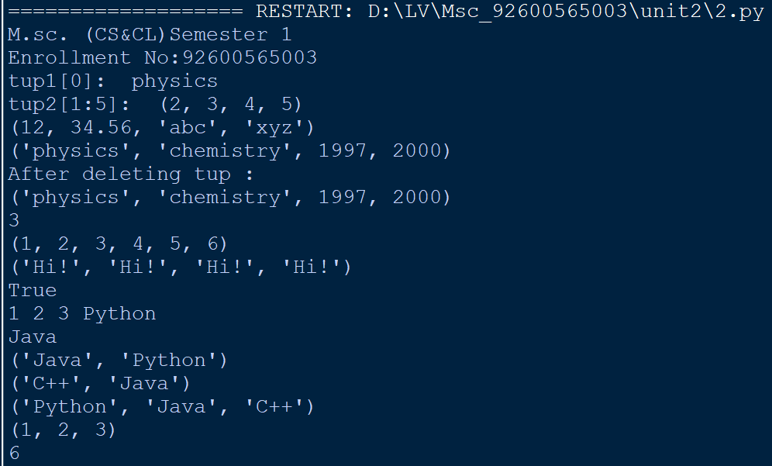

Conclusion:
This practical demonstrated the immutability of Python tuples and how to perform operations like indexing, slicing, and accessing tuple elements using methods like count() and index().
Practical No. 13

Objective: Python Programs to demonstrate the use of dictionary and various
functions of it

Source Code:
print("M.sc. (CS&CL)Semester 1")
print("Enrollment No:92600565003")
def demonstrate_dictionary_operations():
print(f"Student Enrolment No: 92600565003\n")

# 1. Creating a Dictionary
student = {
"name": "lakshyadeepsinh",
"age": 21,
"course": "M.Sc. CS&CL",
"marks": 85
}
print("Initial Dictionary:", student)

# 2. Accessing Values
print("Name:", student["name"])
print("Course (using get()):", student.get("course"))
print("Non-existent Key (with default):", student.get("gpa", "Not Available"))

# 3. Adding and Updating Elements
student["age"] = 22 # Direct assignment
student.update({"city": "Vadodara", "marks": 90}) # Batch update
print("After Update:", student)

# 4. Built-in Retrieval Functions
print("Keys:", list(student.keys()))
print("Values:", list(student.values()))
print("Items (Key-Value pairs):", list(student.items()))

# 5. Removing Elements
removed_val = student.pop("marks")
print(f"Popped 'marks': {removed_val}")

last_item = student.popitem() # Removes last inserted item
print(f"Popped last item: {last_item}")

del student["age"]
print("After deleting 'age':", student)

# 6. Copying and Clearing
temp_dict = student.copy()
temp_dict.clear()
print("Cleared Dictionary:", temp_dict)

if __name__ == "__main__":
demonstrate_dictionary_operations()

Output:
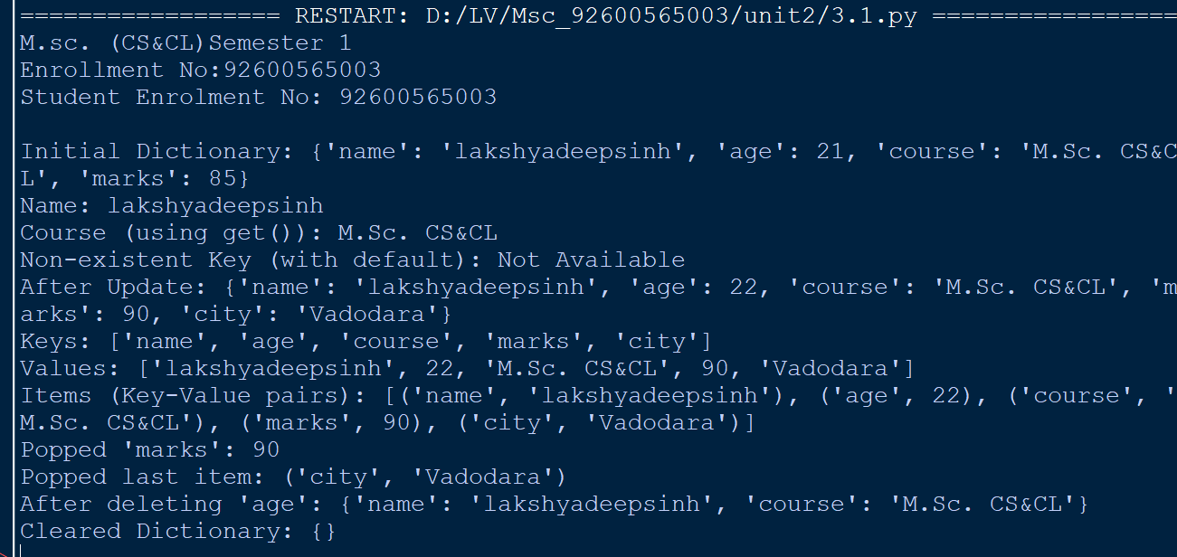

Conclusion:
In this practical, key-value data manipulation was implemented successfully using Python dictionaries and built-in methods such as keys(), values(), items(), and get().
Practical No. 14

Objective: Python Programs to create a function (Make your own assumptions)

Source Code:

print("M.sc. (CS&CL)Semester 1")
print("Enrollment No:92600565003")

def area_of_circle(radius):
return 3.14159 * (radius ** 2)

def area_of_triangle(base, height):
return 0.5 * base * height

def area_of_square(side):
return side ** 2

def area_of_rectangle(length, width):
return length * width

def area_of_trapezoid(base1, base2, height):
return 0.5 * (base1 + base2) * height

def interest(principal, rate, time):
return (principal * rate * time) / 100

print("Circle Area (r=7):", area_of_circle(7))
print("Triangle Area (b=8, h=5):", area_of_triangle(8, 5))
print("Square Area (s=6):", area_of_square(6))
print("Area of Rectangle:", area_of_rectangle(10, 5))
print("Area of Trapezoid:", area_of_trapezoid(6, 10, 4))
print("Interest:", interest(1000, 5, 2))

Output:
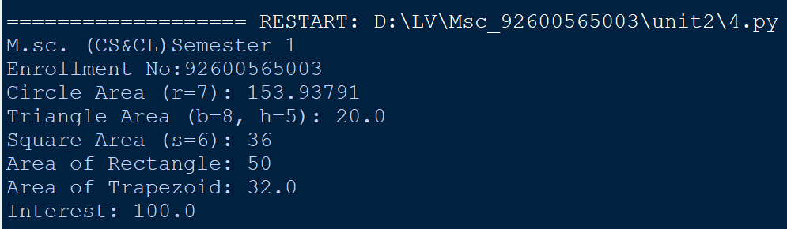

Conclusion:
This practical demonstrated the modular coding approach in Python by defining custom functions using the def keyword, executing logic, and returning values to the caller.
Practical No. 15

Objective: Python Programs to demonstrate use of various arguments which
can be passed to functions

Source Code:
print("M.sc. (CS&CL)Semester 1")
print("Enrollment No:92600565003")

# 1. Positional Arguments
def area(w, h):
return w * h

# 2. Default Arguments
def greet(name, msg="Hello"):
print(f"{msg}, {name}!")

# 3. Keyword Arguments
def student_info(name, age):
print(f"Name: {name}, Age: {age}")

# 4. Variable-length Positional Arguments (*args)
def add_all(*numbers):
print("Sum:", sum(numbers))

# 5. Variable-length Keyword Arguments (**kwargs)
def print_details(**details):
for key, value in details.items():
print(f"{key}: {value}")

# Main Execution
print(" Student Enrolment No: 92600565003 ")
print(" Name: Lakshyadeepsinh\n")

# Demonstrating function calls
print("Area:", area(5, 10))
greet("Lakshyadeepsinh")
student_info(age=22, name="Lakshyadeepsinh")
add_all(10, 20, 30)
print_details(Role="Student", City="Rajkot")

Output:
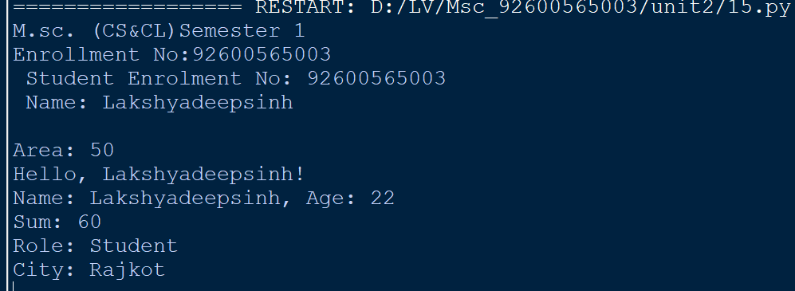

Conclusion:
In this practical, different types of function parameters—including positional, keyword, default, and arbitrary arguments (*args and **kwargs)—were successfully executed and analyzed.
Practical No. 16

Objective: Python Program to demonstrate the use of class

Source Code:

print("M.sc. (CS&CL)Semester 1")
print("Enrollment No:92600565003")
#class&objects
class MyNewClass:
"""This class demonstrates the creation of objects"""
num=100
def hello(self):
print("hello word")
obj=MyNewClass()
print(obj.num)
obj.hello()
print(MyNewClass.__doc__)

class Employee:
def __init__(self,name,id):
self.id=id
self.name=name

def display(self):
print(self.id,self.name)

emp1=Employee("john",101)
emp2=Employee("David",102)

emp1.display()
emp2.display()

class Student:
def __init__(self):
print("this is non parametrized constructor")
def show(self,name):
print("hello",name)

obj=Student()
obj.show("Lakshyadeepsinh")

Output:
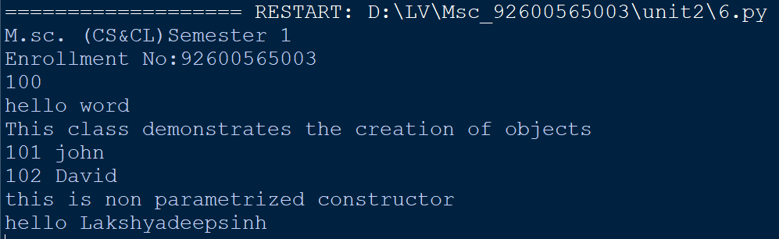

Conclusion:
This practical demonstrated basic Object-Oriented Programming (OOP) by creating a class, instantiating objects, and managing object state through class attributes and instance attributes.
Practical No. 17

Objective: Python Program to demonstrate the concept of inner class

Source Code:
print("M.sc. (CS&CL)Semester 1")
print("Enrollment No:92600565003")

class University:
def __init__ (self,university_name):
self.university_name = university_name

class Student:
def __init__ (self,name,enrollment_no,department):
self.name = name
self.enrollment_no = enrollment_no
self.department = department

def display(self):
print("Student Name:",self.name)
print("Entollment_No:",self.enrollment_no)
print("Department:",self.department)

univ = University("Marwadi University")
stud = Student("Lakshyadeepsinh Vala",92600565003,"FoCa")

print("University:",univ.university_name)
stud.display()

Output:
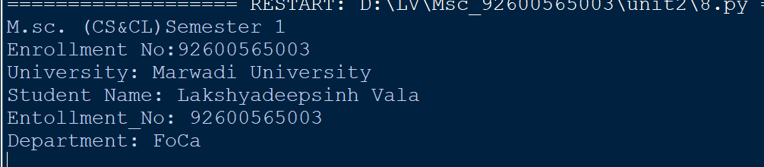

Conclusion:
In this practical, the concept of nested classes was implemented. The inner class was successfully instantiated within the outer class to logically group related functionalities.
Practical No. 18

Objective: Python program to demonstrate the use of methods

Source Code:
print("M.sc. (CS&CL)Semester 1")
print("Enrollment No:92600565003")

class Student:
# Constructor
def __init__(self, name, marks):
self.name = name
self.marks = marks

# Method 1: Display student details
def display_info(self):
print(f"Student Name: {self.name}")
print(f"Marks: {self.marks}")

# Method 2: Calculate grade based on marks
def get_grade(self):
if self.marks >= 80:
return "A"
elif self.marks >= 60:
return "B"
else:
return "C"

# Main Execution
print("Student Enrolment No: 92600565003")
print("Name: Lakshyadeepsinh \n")

# Creating an instance of the class
student1 = Student("Lakshyadeepsinh", 85)

# Calling instance methods
student1.display_info()
print("Grade:", student1.get_grade())

Output:
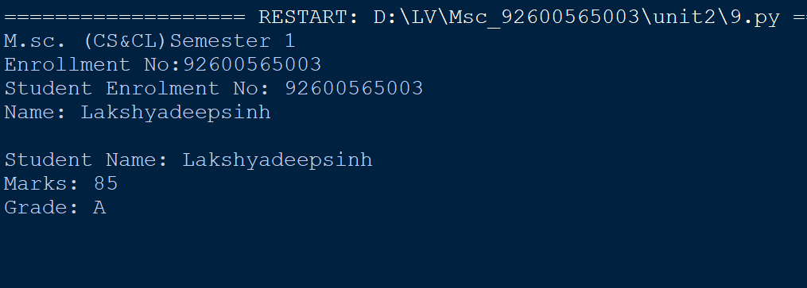

Conclusion:
This practical demonstrated how instance methods access and modify object state using the self reference during program execution.
Practical No. 19

Objective: Python program to demonstrate various types of methods

Source Code:
print("M.sc. (CS&CL)Semester 1")
print("Enrollment No:92600565003")

class Student:
# Class Variable (Shared across all instances)
college_name = "Marwadi University"

def __init__(self, name, marks):
# Instance Variables
self.name = name
self.marks = marks

# 1. Instance Method (Works with instance attributes using 'self')
def display_details(self):
print(f"Student Name: {self.name}")
print(f"Marks: {self.marks}")

# 2. Class Method (Works with class attributes using 'cls')
@classmethod
def get_college(cls):
print(f"College Name: {cls.college_name}")

# 3. Static Method (Independent utility method, uses neither 'self' nor 'cls')
@staticmethod
def is_passing(marks):
return marks >= 40

# Main Execution
print("=== Student Enrolment No: 92600565003 ===")
print("=== Name: Lakshyadeepsinh ===\n")

# Creating an instance
s1 = Student("Lakshyadeepsinh", 85)

# 1. Calling Instance Method
print("--- Instance Method ---")
s1.display_details()

# 2. Calling Class Method
print("\n--- Class Method ---")
Student.get_college()

# 3. Calling Static Method
print("\n--- Static Method ---")
result = Student.is_passing(s1.marks)
print(f"Is Student Passing? {result}")

Output:
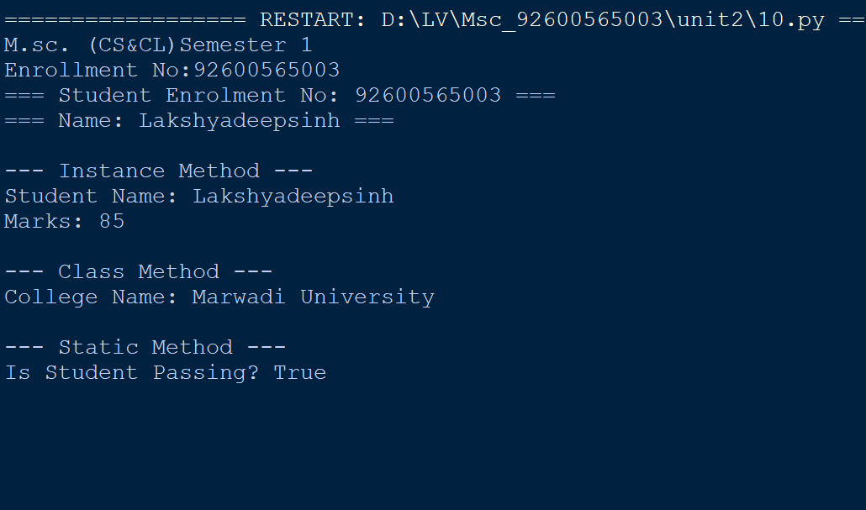

Conclusion:
In this practical, the distinctions between Instance Methods, Class Methods (@classmethod), and Static Methods (@staticmethod) were successfully demonstrated based on how they access class variables and instance attributes.

Practical No. 20
Objective: Write a Python program to show method overloading by adding two
numbers and three numbers using the same method name.

Source Code:
print("M.sc. (CS&CL)Semester 1")
print("Enrollment No:92600565003")

class Calculator:
def add(self, a, b, c=None):
if c is not None:
return a + b + c
else:
return a + b

print(" Student Enrolment No: 92600565003 ")
print(" Name: Lakshyadeepsinh \n")

calc = Calculator()

# Adding two numbers using add()
sum_two = calc.add(10, 20)
print("Sum of two numbers (10 + 20):", sum_two)

# Adding three numbers using the same add() method name
sum_three = calc.add(10, 20, 30)
print("Sum of three numbers (10 + 20 + 30):", sum_three)

Output:
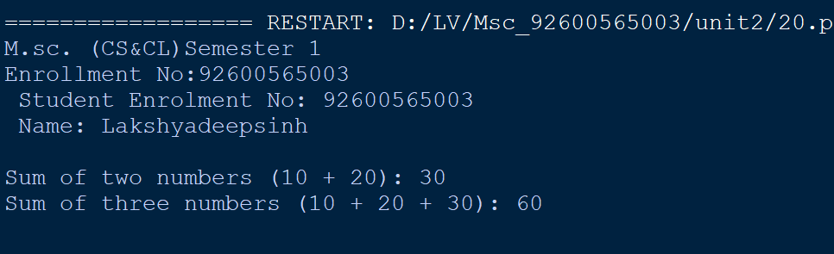

Conclusion:
This practical demonstrated method overloading in Python. By using default arguments within a single method, the program successfully handled addition for both two and three numbers seamlessly.

Practical No. 21

Objective: Write a Python program to show method overriding using a parent
class Animal and a child class Dog.

Source Code:
print("M.sc. (CS&CL)Semester 1")
print("Enrollment No:92600565003")

# Parent Class
class Animal:
def speak(self):
print("Animal makes a generic sound.")

# Child Class overriding the speak method
class Dog(Animal):
def speak(self):
print("Dog barks: Woof Woof!")

# Main Execution
print("Student Enrolment No: 92600565003 ")
print("Name: Lakshyadeepsinh \n")

# Object of Parent Class
generic_animal = Animal()
print("Calling Animal's speak method:")
generic_animal.speak()

print()

# Object of Child Class
dog = Dog()
print("Calling Dog's overridden speak method:")
dog.speak()

Output:

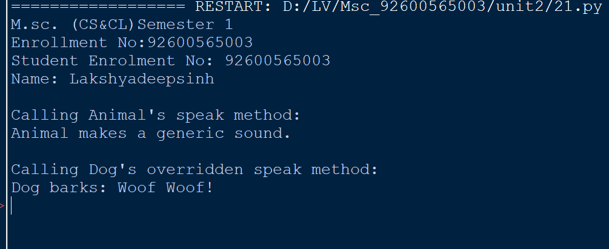
Conclusion:
In this practical, runtime polymorphism via method overriding was implemented. The child class (Dog) successfully redefined and replaced the implementation of a method inherited from the parent class (Animal).

